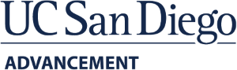

Resume Review
Workshops & Individual Counseling

Our Resume Review assistance is free and available to everyone. You can choose to connect for an individual session or join a workshop where you will learn how to develop an effective online resume and application. Gain knowledge of how to improve and tailor your resume and cover letter, and how to make yourself more marketable in your job search.

Contact our Talent Outreach Advisor by emailing us at employment@ucsd.edu.

